
Starters
3 Cheese Garlic Bread $10.90
Welsh Rarebit Vg $12.90
Seeded mustard, 3 cheeses and
Worcestershire sauce, smashing!
Breaded Mushrooms Vg $14.00
Arancini Balls G/F, (V on request) $14.00
Soup of the Day (G/F on request) $12.50
Pigs in blanket $14.90
Battered Lincolnshire sausage $12.00
Prawn Cocktail $14.90
Dirty Bird Chicken Tenders G/F $14.90
w chipotle aioli
Lemon Pepper Cod $14.50
Traditional Pork Pie $22.00
Main FARE
Classic Fox & Hounds Pies $30.00
Beef & Guinness or Chicken Leek & Bacon, served with mash and peas OR
Cottage Pie served with veggies
Beer Battered Atlantic Cod $28.00
with beer battered chips & mushy peas, served with tartar sauce
Fish of the Day G/F $30.00
See board for details
BBQ Ribs $39.00
A Succulent rack of pork ribs with tender meat hanging off the bone in an amazing secret sauce & beer battered thick chips
Classic Bangers & Mash $27.00
Cumberland pork sausage served with onion gravy on creamy mash & peas …
Classic Lamb Shank G/F $36.00
served W gravy on creamy mash & peas
Lambs Fry G/F $29.00
Seasoned liver with bacon served with onion gravy on creamy mash & peas
14hr Slow Cooked Beef G/F $36.00
Beef cheek served with mash and veg
Chefs Choice Cut Steak G/F $41.00
350gm T-Bone or 185gm Eye Fillet W mash & Veg or Chips and Slaw, choice Peppercorn, Mushroom or Red wine Jus
Available 11 – 4pm only
Traditional Ploughman’s Platter for 2 $39.00
leg ham, duo of cheese, pickled onions, celery, apple, assorted relishes & bread roll…to share add a pork pie for $12.00

Main FARE
Roast Dinner $25.00
(Fri after 5pm all Sat & Sun) chat potatoes, local skin pumpkin, roasted carrots, peas
Vegetarian Nut Roast (weekend) $24.00
Made up of nuts, cheese, capsicum, carrot, celery, onion, and breadcrumbs.
Duo of Roast Pork & Beef (weekend) $27.00
Giant Yorkie (after 4pm Sundays only)$29.00
Roast meat served with chat potatoes, local skin pumpkin, roasted carrots, peas
Toad in the Hole $28.00
Lincolnshire pork sausage in Yorkshire pudding with gravy, mash, onions & peas
Chicken Schnitzel $27.50
with beer battered chips…choose from peppercorn, mushroom sauce or red wine gravy… home made

Chilli Con Carne – V, G/F $24.00
Vegan plant mince with kidney beans,
tomato and onion served with
rice and pappadam
Chefs Vegan Curry, V, $28.00
Vegetables with chefs choice of curry & beer battered thick chips, rice and pappadam, see board for Details
Fox’s Chefs Salad (see todays board) $23.00
Add chicken $5.00
Add Prawns $7.00
Vegan Lasagne V $28.00
Plant based mince and eggplant served with chips and peas
Chicken Parmigiana $29.50
Topped with Mozzarella & Parmesan cheese, Leg Ham, Napoli sauce served with Chips. All home made, Amazing!
British Curry ½, ½ $29.50
Chef’s curry of the day with rice
Naan bread and Chips
Cornish or Cheese & Onion Pasty $26.50
served with beer battered chips, pickled onions, Branston pickle
V = Vegan, Vg = Vegetarian, G/F = Gluten Free
All gravies are gluten free

SIDES
Beer Battered Chips $10.00
with gravy or curry sauce
Mash $7.00
Onion Rings $7. 00
Extra Yorkshire pudding $2.00
Extra Gravy $2.00
Murder Mystery Dinners
- Game of Crowns Medieval
- Escape Room
- Grand Gatsby – 1920’s
- Sherlock Holmes Baker Street
Murder someone anytime, we’ll be sure you get away with it!
Real friends help you hide the body
Really good friends, help you get rid of the witness!
Minimum of 12, Maximum of 50 people to have your own murder. Great for birthdays or just an excuse to Murder!
$85pp includes 3 course dinner & host.
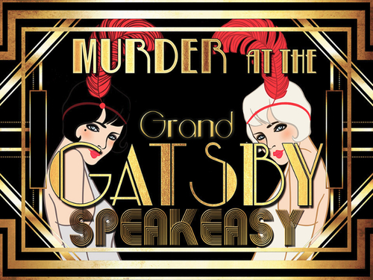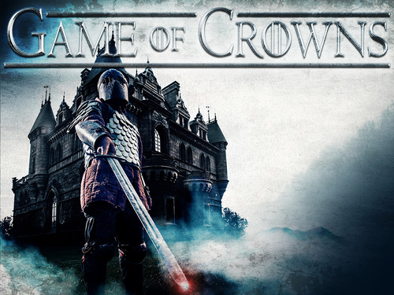

Special Events Public 2023-24

Mar 17th – St. Patricks Day Live entertainment
April 22nd - St Georges Day Medieval Banquet knights battle and Morris dancers $65pp
May 1st – Morris Dancers
June 24th - Scottish Tattoo , Brisbane pipes
‘A Gathering of Clans’ $65pp
July 1st-31st Christmas in July – bookings only
October 3rd - Morris Dancers
October 14th - Battle of Hastings Tribute Dinner Murder $85pp- Live Combat Fighting
October 21st Dr Who Murder Mystery $95pp
Nov 5th – Guy Fawkes Night $65pp- fireworks
November 25th – St. Andrews Dinner $65pp
Dec 25th – Christmas Day $150pp lunch only
Jan 25th – Burns Supper $65pp- address to the Haggis, poetry, bagpiper

All events are bookings only, with deposits required. Children’s prices are 12-17 $30. Under 12 $15. Different menu applies

Sweets
Apple & Rhubarb Crumble $14.90
served warm with ice cream &
vanilla bean anglaise

Raspberry Eton Mess $14.00
layered with meringue, raspberries & whipped cream

Sticky Date Pudding $14.00
served warm butterscotch sauce
& ice cream
Chocolate Fudge cake $14.00
served with warm chocolate sauce
& ice cream

Knickerbocker Glory $14.00
Flaked almonds with ice cream
cream & berries
Spotted Dick $14.90
with anglaise and ice cream
Our Decadent & Delicious Scones $11.50
2 scones served warm with our own
jam & freshly whipped cream
Vegan Carrot Cake $14 .00
with Vegan Vanilla Ice Cream
Ice Cream
3 scoops with a choice of Vanilla or Cookies and Cream or Rainbow $8.50

Health Regulations GGCC
We are not permitted to allow food to be taken off the premises, sorry no doggie bag. As per instructions from Gold Coast City Council

Payment

please note- one bill per table -no split bills.
1.50% merchant service fee applies to Visa & Mastercard
AMEX 1.8% and EFTPOS 0%.
15% surcharge applies public holidays
Open 365 days a year

